Q1A: ANS:

select soh.SalesOrderNumber, p.Name, psc.Name, pc.Name, sod.UnitPrice, sod.UnitPriceDiscount, sod.LineTotal

FROM [Sales].[SalesOrderHeader] soh

inner join [Sales].[SalesOrderDetail] sod

on soh.SalesOrderID = sod.SalesOrderID

inner join [Production].[Product] p

on p.ProductID = sod.ProductID

inner join [Production].[ProductSubcategory] psc

on p.ProductSubcategoryID = psc.ProductSubcategoryID

inner join [Production].[ProductCategory] pc

on pc.ProductCategoryID = psc.ProductCategoryID

order by p.Name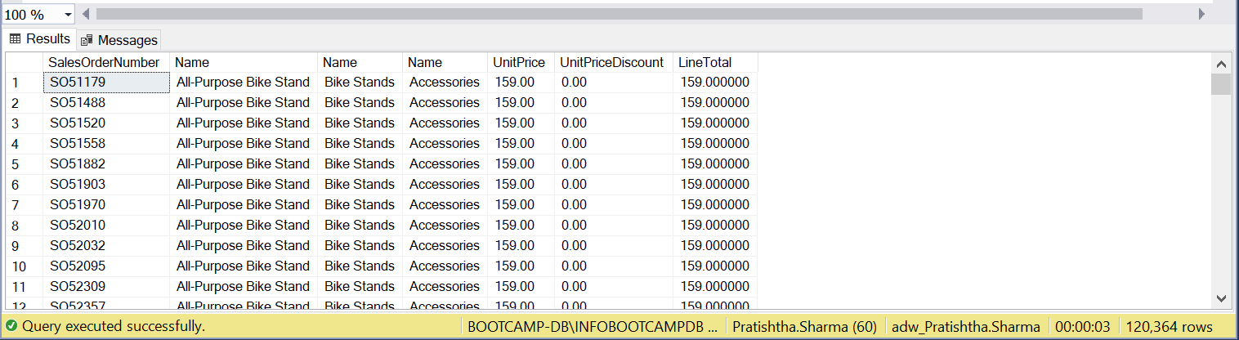

Q1B: ANS:

select p.ProductID, p.Name, psc.ProductSubcategoryID, psc.Name, pc.ProductCategoryID, pc.Name

from [Production].[Product] p

left join [Production].[ProductSubcategory] psc

on p.ProductSubcategoryID = psc.ProductSubcategoryID

left join [Production].[ProductCategory] pc

on psc.ProductCategoryID = pc.ProductCategoryID

order by p.Name

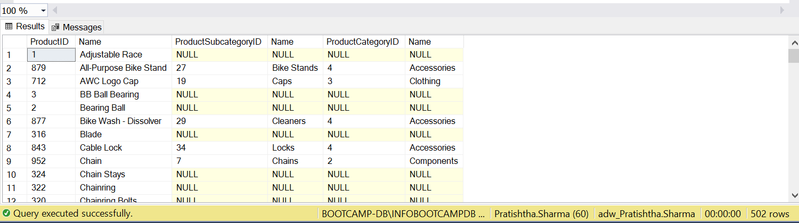

Q2: ANS:

select pc.Name, soh.OrderDate, sum(soh.SubTotal)

from [Sales].[SalesOrderHeader] soh

join [Sales].[SalesOrderDetail] sod

on sod.SalesOrderID = soh.SalesOrderID

join [Production].[Product] p

on p.ProductID = sod.ProductID

join [Production].[ProductSubcategory] psc

on p.ProductSubcategoryID = psc.ProductSubcategoryID

join [Production].[ProductCategory] pc

on pc.ProductCategoryID = psc.ProductCategoryID

where month(soh.OrderDate) = 12 and year(soh.OrderDate) = 2003

group by pc.Name, soh.OrderDate

order by soh.OrderDate

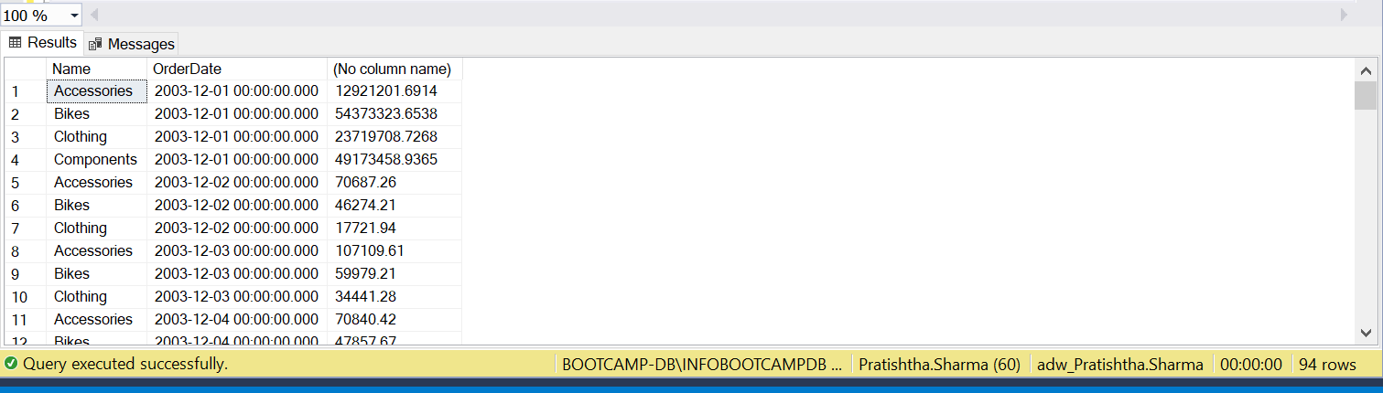

Q3: ANS:

select soh.SalesOrderID, sr.Name, sr.ReasonType, soh.ShipDate, soh.SubTotal, soh.TaxAmt, soh.Freight, soh.TotalDue

from [Sales].[SalesOrderHeader] soh

join [Sales].[SalesOrderHeaderSalesReason] sohsr

on soh.SalesOrderID = sohsr.SalesOrderID

join [Sales].[SalesReason] sr

on sohsr.SalesReasonID = sr.SalesReasonID

where sr.Name <> 'Quality' and sr.Name <> 'Manufacturer'

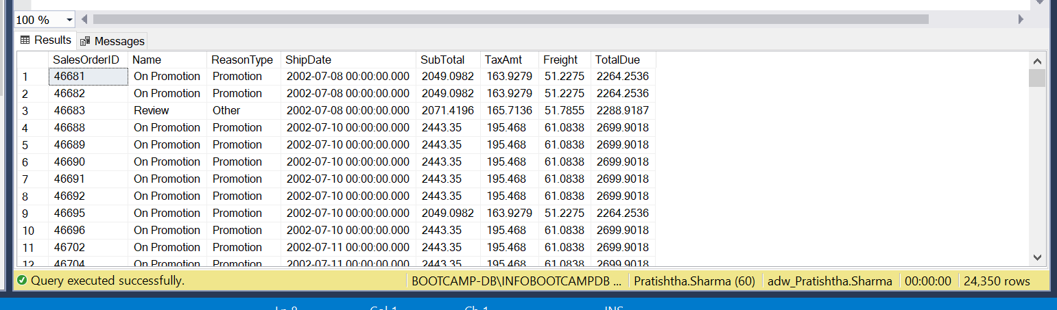

Q4: ANS:

select distinct(p.Name)

from [Sales].[SpecialOffer] so

join [Sales].[SpecialOfferProduct] sop

on so.SpecialOfferID = sop.SpecialOfferID

join [Production].[Product] p

on p.ProductID = sop.ProductID

where so.DiscountPct <=0.45 and p.Name not like 'R%'

order by p.Name desc

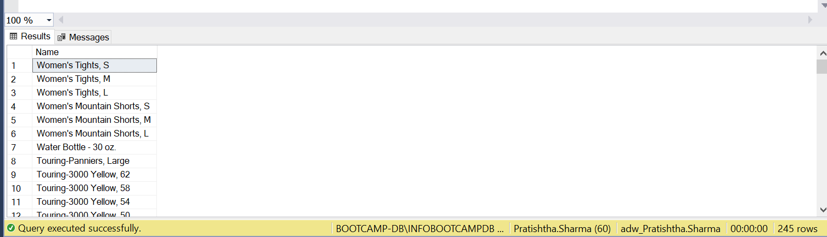

Q5: ANS:

Select distinct(p.Name)

from [Production].[Product] p

where p.Name like'%[-,/%0-9]%'

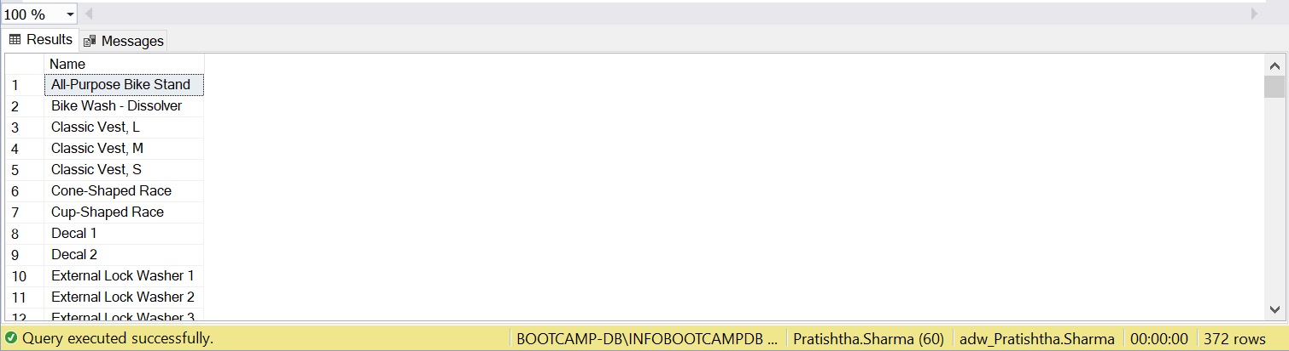

Q6: ANS:

select top 1 sp.Name,(str1.TaxRate), str1.Name

from [Sales].[SalesTaxRate] str1

join [Person].[StateProvince] sp

on str1.StateProvinceID = sp.StateProvinceID

order by str1.TaxRate desc

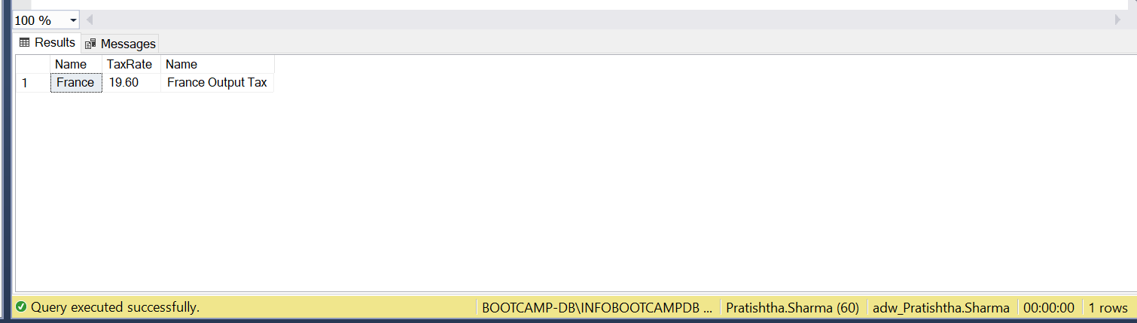

Q7: ANS:

select st.Name, pc.Name, sum(sod.LineTotal) as revenue

from [Production].[ProductCategory] pc

inner join [Production].[ProductSubcategory] psc

on pc.ProductCategoryID = psc.ProductCategoryID

inner join [Production].[Product] p

on p.ProductSubcategoryID = psc.ProductSubcategoryID

inner join [Sales].[SalesOrderDetail] sod

on sod.ProductID = p.ProductID

inner join [Sales].[SalesOrderHeader] so

on so.SalesOrderID = sod.SalesOrderID

inner join [Sales].[SalesTerritory] st

on st.TerritoryID = so.TerritoryID

group by st.Name, pc.Name

order by 1

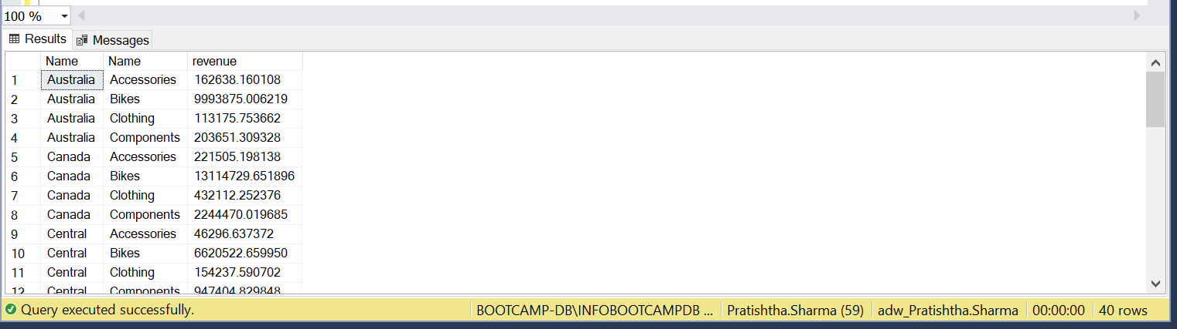

Q8: ANS:

SELECT

CASE

WHEN DATEDIFF(YEAR, HireDate, getdate()) < 15 THEN 'LESS than 15'

WHEN DATEDIFF(YEAR, HireDate, getdate()) BETWEEN 15 AND 18 THEN 'BETWEEN 15 AND 18'

WHEN DATEDIFF(YEAR, HireDate, getdate()) > 18 THEN 'Greater than 18'

END AS Experience, SUM(SOH.SubTotal) as TotalSales ,COUNT(E.EmployeeID) AS 'Number of Employees'

FROM HumanResources.Employee E

LEFT JOIN Sales.SalesPerson SP

ON E.EmployeeID = SP.SalesPersonID

INNER JOIN Sales.SalesOrderHeader SOH

ON E.EmployeeID = SOH.SalesPersonID

where SOH.SalesPersonID = 275

Group by CASE

WHEN DATEDIFF(YEAR, HireDate, getdate()) < 15 THEN 'LESS than 15'

WHEN DATEDIFF(YEAR, HireDate, getdate()) BETWEEN 15 AND 18 THEN 'BETWEEN 15 AND 18'

WHEN DATEDIFF(YEAR, HireDate, getdate()) > 18 THEN 'Greater than 18'

END

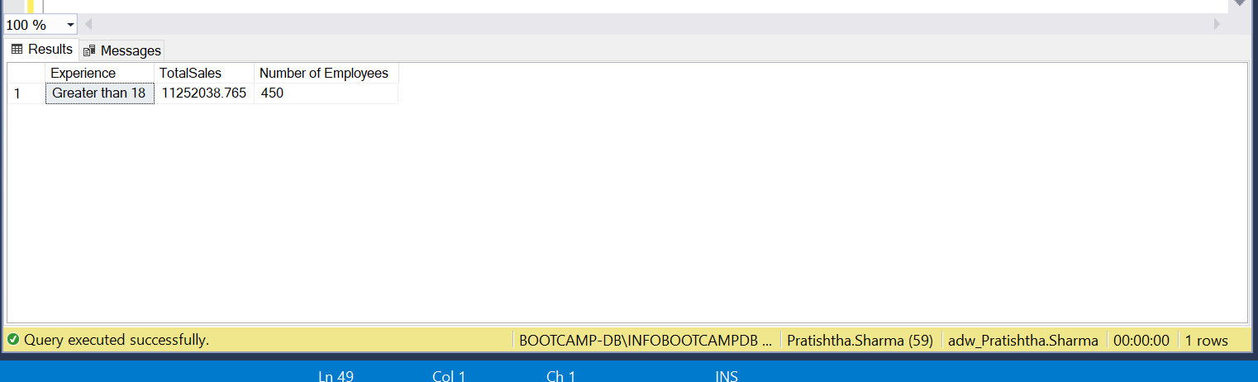

Q9: ANS:

SELECT PC.Name,AVG(SD.OrderQty)

FROM [Sales].[SalesOrderDetail] SD

INNER JOIN [Sales].[SalesOrderHeader] SOD

ON SOD.SalesOrderID = SD.SalesOrderID

INNER JOIN [Production].[Product] P

ON SD.ProductID = P.ProductID

INNER JOIN [Production].[ProductSubcategory] PSC

ON P.ProductSubcategoryID = PSC.ProductSubcategoryID

INNER JOIN [Production].[ProductCategory] PC

ON PC.ProductCategoryID = PSC.ProductCategoryID

WHERE (DATEPART(MONTH, SOD.OrderDate) = 4 OR DATEPART(MONTH, SOD.OrderDate) = 5) AND DATEPART(YEAR, SOD.OrderDate) = 2003

GROUP BY PC.Name

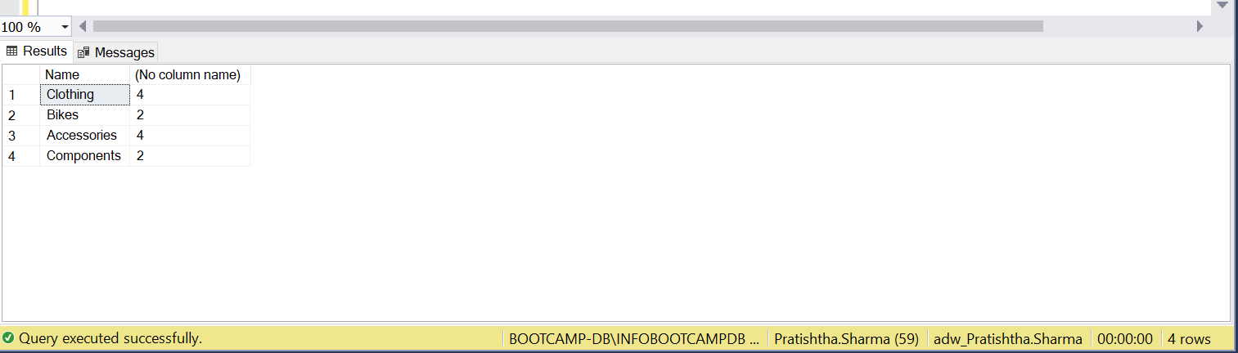

Q10A: ANS:

with cte1 as ( select pc.Name, month(soh.OrderDate) as months, sum(sod.OrderQty) as quantity_Clothing

from [Production].[ProductCategory] pc

join [Production].[ProductSubcategory] psc

on pc.ProductCategoryID = psc.ProductCategoryID

join [Production].[Product] p

on psc.ProductSubcategoryID = p.ProductSubcategoryID

join [Sales].[SalesOrderDetail] sod

on sod.ProductID = p.ProductID

join [Sales].[SalesOrderHeader] soh

on sod.SalesOrderID = soh.SalesOrderID

where pc.Name = 'Clothing' and year(soh.OrderDate) = 2003

group by pc.Name, month(soh.OrderDate)),

cte2 as ( select pc.Name, month(soh.OrderDate) as months, sum(sod.OrderQty) as quantity_bike

from [Production].[ProductCategory] pc

join [Production].[ProductSubcategory] psc

on pc.ProductCategoryID = psc.ProductCategoryID

join [Production].[Product] p

on psc.ProductSubcategoryID = p.ProductSubcategoryID

join [Sales].[SalesOrderDetail] sod

on sod.ProductID = p.ProductID

join [Sales].[SalesOrderHeader] soh

on sod.SalesOrderID = soh.SalesOrderID

where pc.Name = 'Bikes' and year(soh.OrderDate) = 2003

group by pc.Name, month(soh.OrderDate))

select 2003 , cte1.months, cte1.quantity_Clothing, cte2.quantity_bike

from cte1 inner join cte2

on cte2.months = cte1.months

where cte1.quantity_Clothing < cte2.quantity_bike

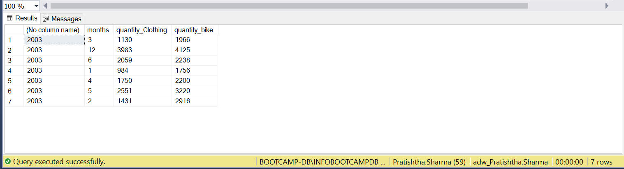

Q10B: ANS:

select LEFT(p.Name,10) as Product_Name_Broken, pd.Description

from [Production].[Product] p

join [Production].[ProductModel] pm

on p.ProductModelID = pm.ProductModelID

join [Production].[ProductModelProductDescriptionCulture] pmpdc

on pmpdc.ProductModelID = pm.ProductModelID

join [Production].[ProductDescription] pd

on pd.ProductDescriptionID = pmpdc.ProductDescriptionID

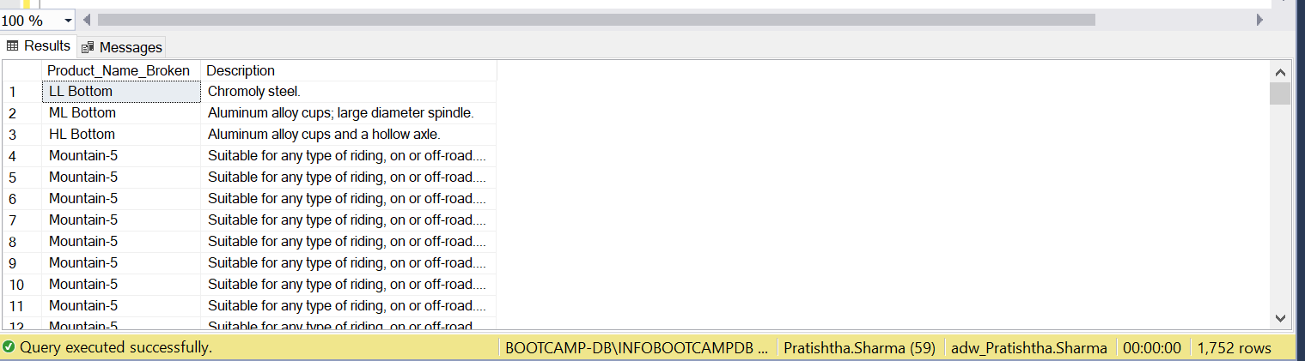

Q11: ANS:

select LEFT(p.Name,10) as Product_Name_Broken, pd.Description, len(p.Name) - 10 as no_of_char_deleted

from [Production].[Product] p

join [Production].[ProductModel] pm

on p.ProductModelID = pm.ProductModelID

join [Production].[ProductModelProductDescriptionCulture] pmpdc

on pmpdc.ProductModelID = pm.ProductModelID

join [Production].[ProductDescription] pd

on pd.ProductDescriptionID = pmpdc.ProductDescriptionID

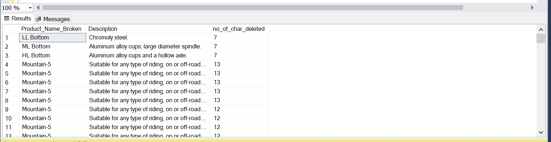

Q12: ANS:

select sum(sod.OrderQty)

from [HumanResources].[Employee] e

join [Sales].[SalesOrderHeader] soh

on e.EmployeeID = soh.SalesPersonID

join [Sales].[SalesOrderDetail] sod

on sod.SalesOrderID = soh.SalesOrderID

where e.MaritalStatus = 'M' and (GETDATE() - e.BirthDate)>=40 and (GETDATE() - e.BirthDate)<=50 and (soh.OrderDate between '01/07/2003' and '01/10/2003')

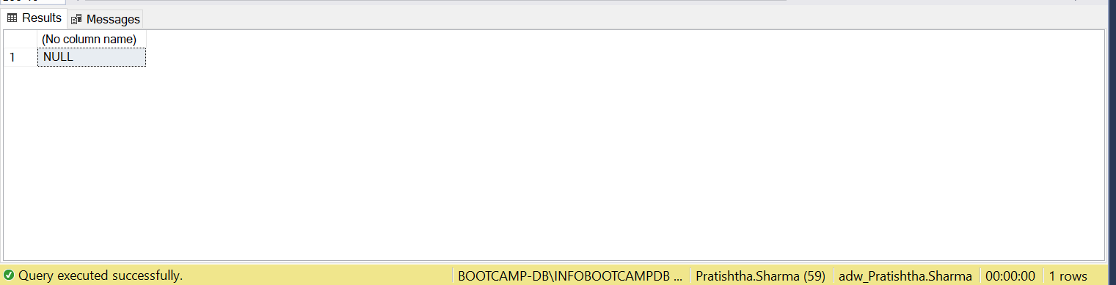

Q13: ANS:

SELECT COUNT(SC.CustomerID) AS "Count_of_Customers"

FROM (SELECT SOH.CustomerID,

COUNT(DISTINCT(PSC.ProductCategoryID)) AS [Count]

FROM Sales.Customer C

JOIN Sales.SalesOrderHeader SOH

ON C.CustomerID = SOH.CustomerID

JOIN Sales.SalesOrderDetail SOD

ON SOH.SalesOrderID = SOD.SalesOrderID

JOIN Production.Product P

ON SOD.ProductID = P.ProductID

JOIN Production.ProductSubcategory PSC

ON P.ProductSubcategoryID = PSC.ProductSubcategoryID

JOIN Production.ProductCategory PC

ON PSC.ProductCategoryID = PC.ProductCategoryID

GROUP BY SOH.CustomerID) AS SC WHERE SC.[Count]=4

GROUP BY SC.[Count]

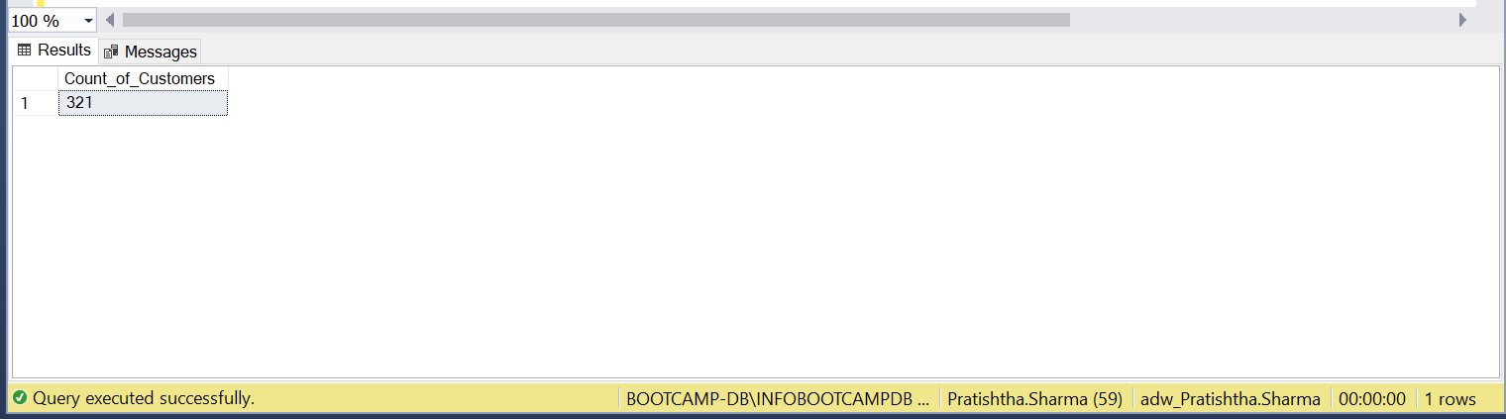

Q14: ANS:

select pc.Name, sum(sod.LineTotal) as 'Total Sales', round(sum(sod.LineTotal)*100/(select sum( sod.LineTotal) from [Sales].[SalesOrderDetail] sod inner join[Sales].[SalesOrderHeader] soh on sod.SalesOrderID = soh.SalesOrderID where month(soh.OrderDate) = 6 and year(soh.OrderDate) = 2004),2) as 'Percent to Total'

from [Sales].[SalesOrderHeader] soh

join [Sales].[SalesOrderDetail] sod

on sod.SalesOrderID = soh.SalesOrderID

join [Production].[Product] p

on p.ProductID = sod.ProductID

join [Production].[ProductSubcategory] psc

on psc.ProductSubcategoryID = p.ProductSubcategoryID

join [Production].[ProductCategory] pc

on pc.ProductCategoryID = psc.ProductCategoryID

where month(soh.OrderDate) = 6 and year(soh.OrderDate) = 2004 and (pc.Name = 'Bikes' or pc.Name = 'Accessories')

group by pc.Name

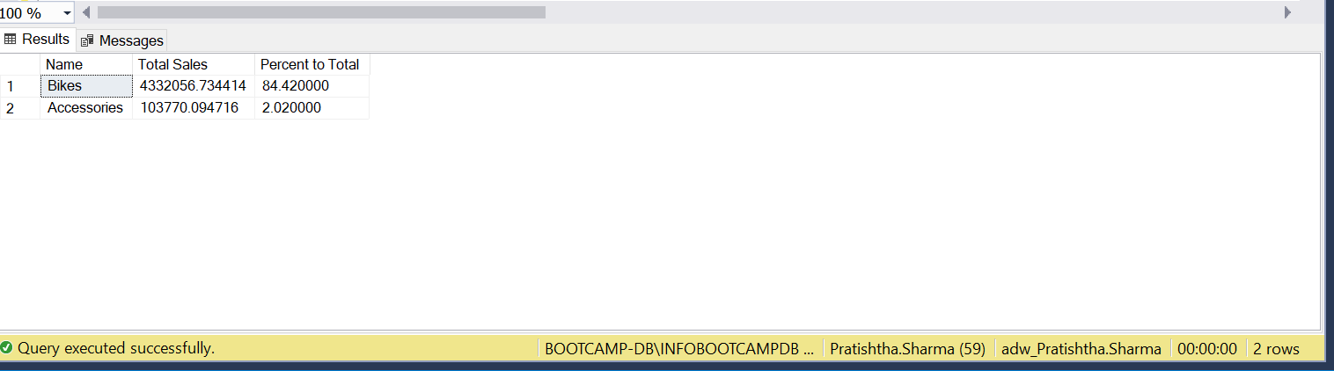

Q15: ANS:

select pc.Name , round(100*(sum(SD.LineTotal)/(select sum(S.LineTotal)

FROM [Sales].[SalesOrderDetail] S

INNER JOIN [Sales].[SalesOrderHeader] SH

ON S.SalesOrderID = SH.SalesOrderID

where Datepart(q, SH.OrderDate) = 2 and Datepart(year, SH.OrderDate) = 2003)), 2)

FROM [Sales].[SalesOrderDetail] SD

INNER JOIN [Sales].[SalesOrderHeader] SH

ON SD.SalesOrderID = SH.SalesOrderID

INNER JOIN [Production].[Product] P

ON SD.ProductID = P.ProductID

INNER JOIN [Production].[ProductSubcategory] PSC

on PSC.ProductSubcategoryID = P.ProductSubcategoryID

inner join [Production].[ProductCategory] pc

on PSC.ProductCategoryID = pc.ProductCategoryID

where Datepart(q, SH.OrderDate) = 2 and Datepart(year, SH.OrderDate) = 2003

group by pc.Name

order by 2 desc

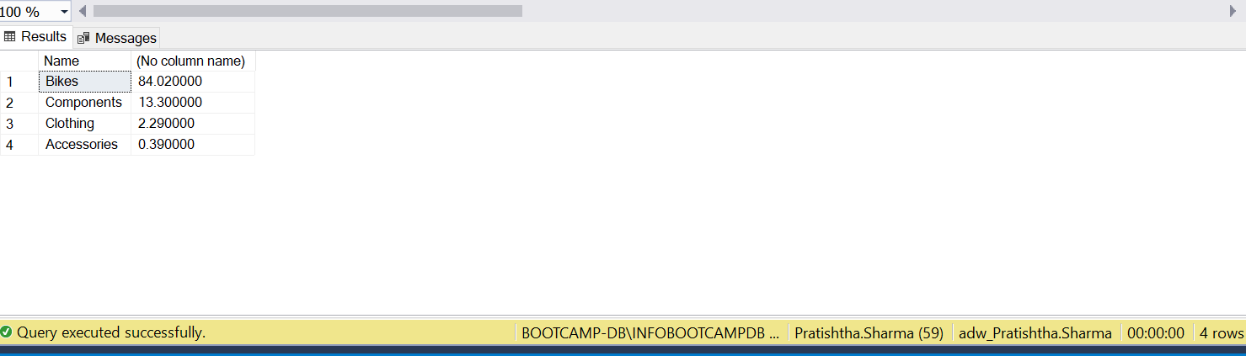

Q16: ANS:

select top 1 pc.Name, max(sod.OrderQty) as 'Maximum Product Sold', min(sod.OrderQty) as 'Minimum Product Sold', max(sod.OrderQty) - min(sod.OrderQty) as 'Difference Between Max and Min'

from [Sales].[SalesOrderHeader] soh

join [Sales].[SalesOrderDetail] sod

on sod.SalesOrderID = soh.SalesOrderID

join [Production].[Product] p

on p.ProductID = sod.ProductID

join [Production].[ProductSubcategory] psc

on psc.ProductSubcategoryID = p.ProductSubcategoryID

join [Production].[ProductCategory] pc

on pc.ProductCategoryID = psc.ProductCategoryID

where year(soh.OrderDate) = 2003

group by pc.Name

order by 4 desc

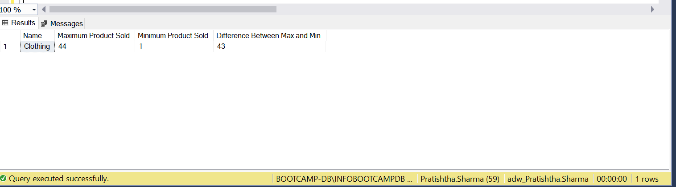

Q17: ANS:

(Select Distinct PSC.Name

FROM [Sales].[SalesOrderDetail] SD

INNER JOIN [Sales].[SalesOrderHeader] SH

ON SD.SalesOrderID = SH.SalesOrderID

INNER JOIN [Production].[Product] P

ON SD.ProductID = P.ProductID

INNER JOIN [Production].[ProductSubcategory] PSC

on PSC.ProductSubcategoryID = P.ProductSubcategoryID

inner join [Production].[ProductCategory] pc

on PSC.ProductCategoryID = pc.ProductCategoryID

where pc.Name = 'Clothing' and DATEPART(Month, SH.OrderDate) = 1 and DATEPART(YEAR, SH.OrderDate)=2003)

INTERSECT

(Select Distinct PSC.Name

FROM [Sales].[SalesOrderDetail] SD

INNER JOIN [Sales].[SalesOrderHeader] SH

ON SD.SalesOrderID = SH.SalesOrderID

INNER JOIN [Production].[Product] P

ON SD.ProductID = P.ProductID

INNER JOIN [Production].[ProductSubcategory] PSC

on PSC.ProductSubcategoryID = P.ProductSubcategoryID

inner join [Production].[ProductCategory] pc

on PSC.ProductCategoryID = pc.ProductCategoryID

where pc.Name = 'Clothing' and DATEPART(Month, SH.OrderDate) = 2 and DATEPART(YEAR, SH.OrderDate)=2004)

order by 1

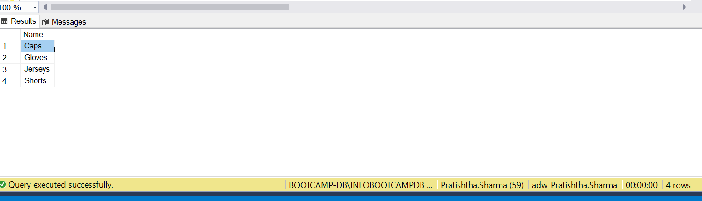

Q18: ANS:

with cte as (select rank() over(partition by pc.Name order by avg(sod.LineTotal)) as rn, pc.Name as p1, p.Name as p2, avg(sod.LineTotal) as average

from [Sales].[SalesOrderHeader] soh

join [Sales].[SalesOrderDetail] sod

on sod.SalesOrderID = soh.SalesOrderID

join [Production].[Product] p

on p.ProductID = sod.ProductID

join [Production].[ProductSubcategory] psc

on psc.ProductSubcategoryID = p.ProductSubcategoryID

join [Production].[ProductCategory] pc

on pc.ProductCategoryID = psc.ProductCategoryID

where year(soh.OrderDate) = 2003

group by pc.Name, p.Name)

select cte.p1 as Product_Category, cte.p2 as Product, cte.average as Minimum_Average_Salary

from cte

where rn =1

order by 1,3

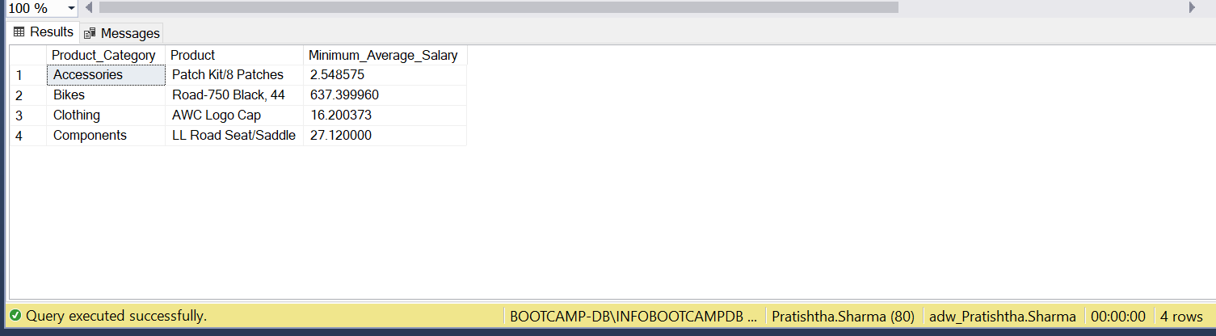

Q19A: ANS:

SELECT TOP 25 SalesOrderDetail.ProductID

INTO CustomProductID_pratishtha

FROM   Production.Product Product

    JOIN Sales.SalesOrderDetail SalesOrderDetail

       ON Product.ProductID = SalesOrderDetail.ProductID

GROUP BY SalesOrderDetail.ProductID

SELECT * FROM CustomProductID_Pratishtha

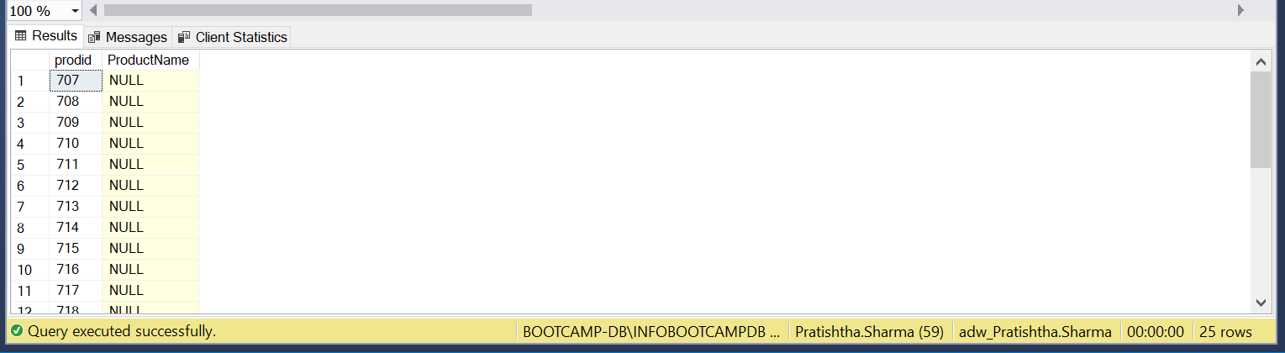

Q19B: ANS:

ALTER TABLE CustomProductID_Pratishtha ADD ProductName VARCHAR(50);

UPDATE CustomProductID_Pratishtha

SET CustomProductID_Pratishtha.ProductName = p.Name

from CustomProductID_Pratishtha s

inner join Production.Product p

on s.prodid = p.ProductID;

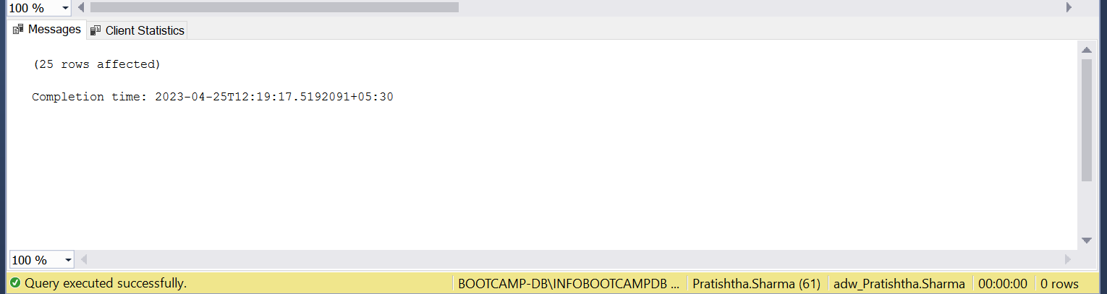

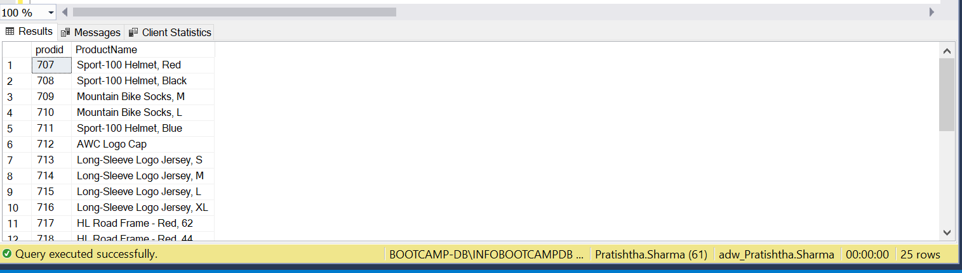

Q20: ANS:

SELECT * INTO SalesOrderDetail_Pratishtha

FROM Sales.SalesOrderDetail

WHERE OrderQty <= 10

         or OrderQty >= 30

SELECT * FROM SalesOrderDetail_Pratishtha

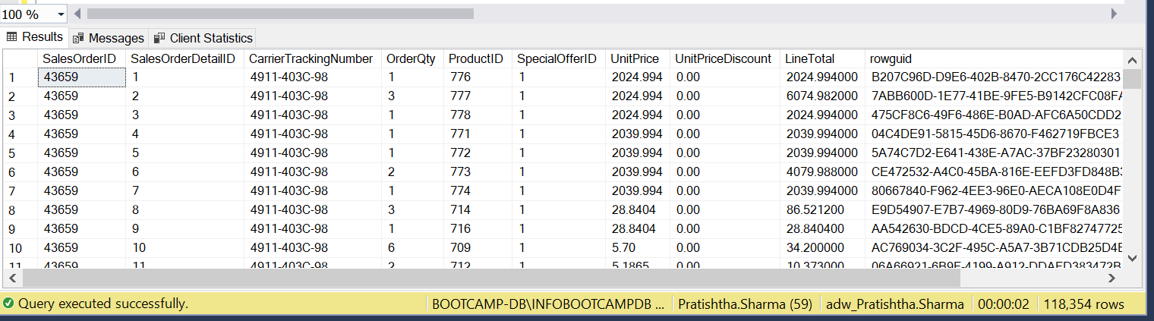

Q21: ANS:

create Table SalesDetails_Pratishtha (

catid int,

scatid int,

cat varchar(255),

scat varchar(255)

);

Insert Into SalesDetails_Pratishtha

Select pc.ProductCategoryID, PSC.ProductSubcategoryID, pc.Name, PSC.Name

from [Production].[ProductSubcategory] PSC

inner join [Production].[ProductCategory] pc

on PSC.ProductCategoryID = pc.ProductCategoryID;

alter table SalesDetails_Pratishtha

add totalrev2003 int;

with c1 as (select sum(sh.TotalDue) as totalrev, s.scatid

from SalesDetails_Pratishtha s

inner join Production.ProductSubcategory psc

on psc.ProductCategoryID = s.catid

inner join Production.Product p

on p.ProductSubcategoryID = psc.ProductSubcategoryID

inner join Sales.SalesOrderDetail sd

on p.ProductID = sd.ProductID

inner join Sales.SalesOrderHeader sh

on sd.SalesOrderID = sh.SalesOrderID

where year(sh.OrderDate) = 2003

group by s.scatid)

update SalesDetails_Pratishtha

set totalrev2003 = c1.totalrev

from SalesDetails_Pratishtha s

inner join c1

on c1.scatid = s.scatid;

alter table SalesDetails_Pratishtha

add totalrev2004 int;

with c2 as (select sum(sh.TotalDue) as totalrev, s.scatid

from SalesDetails_Pratishtha s

inner join Production.ProductSubcategory psc

on psc.ProductCategoryID = s.catid

inner join Production.Product p

on p.ProductSubcategoryID = psc.ProductSubcategoryID

inner join Sales.SalesOrderDetail sd

on p.ProductID = sd.ProductID

inner join Sales.SalesOrderHeader sh

on sd.SalesOrderID = sh.SalesOrderID

where year(sh.OrderDate) = 2004

group by s.scatid)

update SalesDetails_Pratishtha

set totalrev2004 = c2.totalrev

from SalesDetails_Pratishtha s

inner join c2

on c2.scatid = s.scatid;

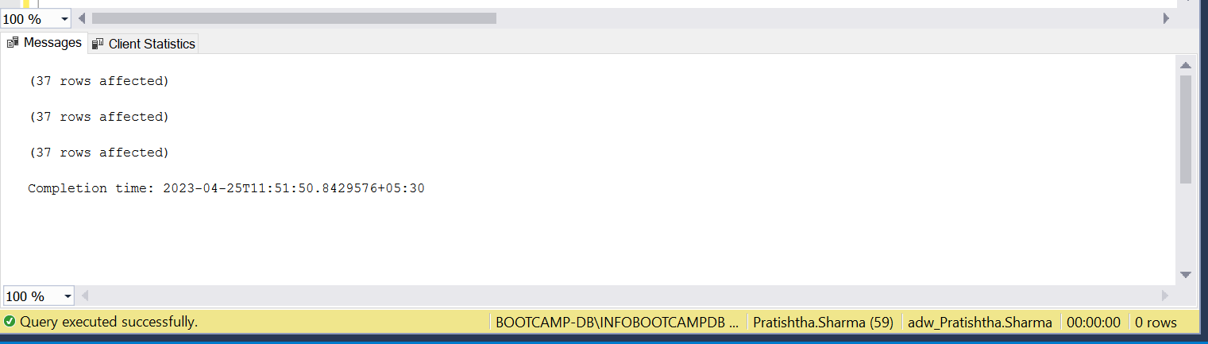

Q22A: ANS:

SELECT *

INTO   Employee_Pratishtha1

FROM   HumanResources.Employee e

ALTER TABLE Employee_Pratishtha1

ADD Salary NUMERIC (38 , 4)

UPDATE a

SET a.Salary = SalesPerson.SalesYTD

FROM Employee_Pratishtha1 a

    JOIN HumanResources.Employee Employee

       ON a.EmployeeID = Employee.EmployeeID

    JOIN Sales.SalesPerson SalesPerson

       ON Employee.EmployeeID = SalesPerson.SalesPersonID

SELECT * FROM Employee_Pratishtha1

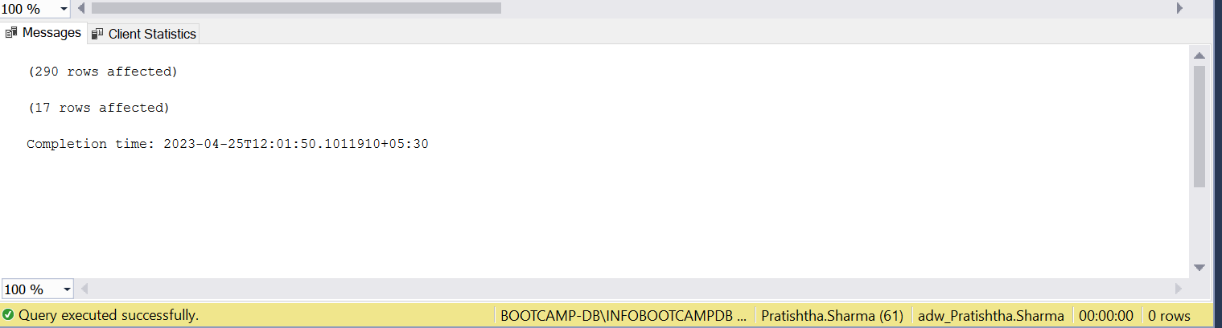

Q22B: ANS:

UPDATE a

SET Salary = (SELECT CASE

WHEN Gender = 'M' THEN Salary * 1.17

WHEN Gender = 'F' THEN Salary * 1.20

END

FROM Employee_Pratishtha1 t

WHERE a.EmployeeID = t.EmployeeID )

FROM Employee_Pratishtha1 a

SELECT * FROM Employee_Pratishtha1;

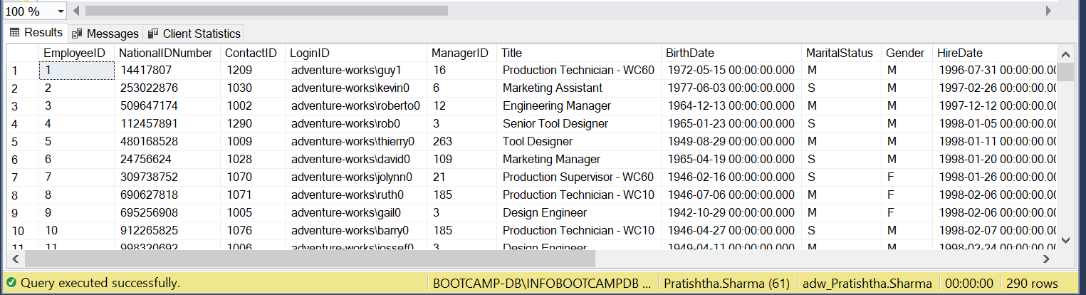

Q23: ANS:

SELECT *

INTO CopyProduct

FROM Production.Product

Update CopyProduct

SET Name = REPLACE(

REPLACE(

REPLACE(

REPLACE(

REPLACE(

REPLACE(

REPLACE(Name, '-', ''), ',', ''), '/', ''),'@',''),'$',''),'&',''),'*','')

FROM CopyProduct

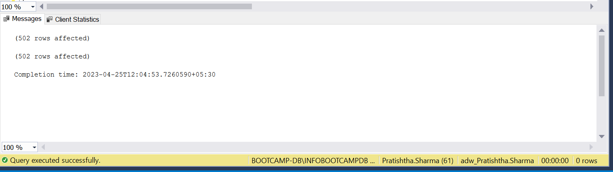

Q24: ANS:

SELECT * INTO SalesOderHeader_Pratishtha

FROM Sales.SalesOrderHeader ;

WITH cte AS (

SELECT ROW_NUMBER () OVER( ORDER BY SalesOrderID) AS RowNumber

FROM SalesOderHeader_Pratishtha)

DELETE FROM cte

WHERE RowNumber like '%00' ;

SELECT * FROM SalesOderHeader_Pratishtha;

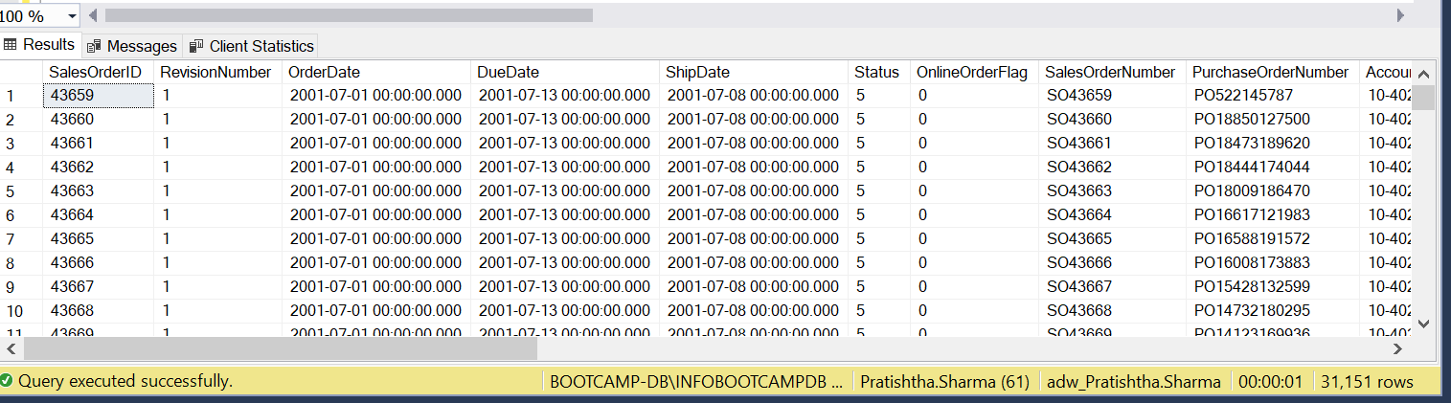

Q25: ANS:

SELECT *

INTO SalesOderDetail_Pratishtha

FROM Sales.SalesOrderDetail ;

WITH CTE

AS (SELECT ROW_NUMBER() OVER (

PARTITION BY ProductID

ORDER BY ProductID

) DUPLICATE

FROM SalesOderDetail_Pratishtha)

DELETE FROM CTE

WHERE DUPLICATE > 1 ;

